Pipedrive

Togzhan Shaptayeva

Introduction

This document describes test plan and results of Pipedrive’s web page [https://www.pipedrive.com/en/test-task-qa.](https://www.pipedrive.com/en/test-task-qa.%20Web)Web page was checked for functionality, usability and compatibility.

Test Plan

**1. Manual testing**

1.1 Layout and content formatting

1.2 Links to other pages and resources

1.3 Usability and user friendliness analysis

1.4 Check for content correctness/spelling, consistency

1.5 Rendering on mobile devices

1.6 Cross browser rendering

**2. Web page HTML analysis**

2.1 Automatic discovery of broken links to pages and resources

2.2 Spell-checking

Test Result

**1. Manual testing**

**Founded issues and bugs**

***1.1 Layout and content formatting***

**1.**

**Main page:** Video on main page does not play  
**Priority:** high

**Environment:**Windows 10 Pro, OS build 19044.2251, Screen resolution 1920 x 1080  
Google Chrome, Version 109.0.5414.75 (Official Build) (64-bit)  
Web site Link <https://www.pipedrive.com/en/test-task-qa>

**Steps to reproduce:**

1. Open web site following the link above
2. Hover your mouse pointer over the Video player and tap to play it
3. Observe the result

**Actual result:**

When user clicks on the “Play button” only the loading icon appears on the screen and is displayed endlessly. The video however does not start. User needs to click several times to make this loading icon disappear.

**Expected result:**

Video should start playing as soon as user clicks on the playing button. If there was a problem while loading the video, an error message should be displayed to the user.

**2.**

**Main page: Software features: Learn more:** When the user opens links and clicks back then the user ends up on the top of the web site  
**Priority:** low

**Environment:**Windows 10 Pro, OS build 19044.2251, Screen resolution 1920 x 1080  
Google Chrome, Version 109.0.5414.75 (Official Build) (64-bit)  
Web site Link <https://www.pipedrive.com/en/test-task-qa>

**Steps to reproduce:**

1. Open web site following the link.
2. Scroll down until Software features are displayed (Email segmentation, Email builder, Email analytics)
3. Click on “Learn more” link of each title.
4. When page opens click on back button to get back to previous page

**Actual result:**

When user opens any of these above mentioned titles’ links they lead them to some pages but when user clicks “back” button user ends up on the top part of the web site.



**Expected result**:

When user clicks “back” button then the user ends up exactly where they were in the previous page. And clicked link or title should be still displayed.

**3.**

**Main page:** Three Software features’ icons are different   
**Priority:** normal

**Environment:**Windows 10 Pro, OS build 19044.2251, Screen resolution 1920 x 1080  
Google Chrome, Version 109.0.5414.75 (Official Build) (64-bit)  
Web site Link <https://www.pipedrive.com/en/test-task-qa>

**Steps to reproduce:**

1. Open web site following the link above
2. Scroll down until reach Software features with check mark icons
3. Compare three icons with each other

**Actual result:**

When user scrolls and reaches software features then first feature’s (Email builder) icon is placed higher than two others and smaller which is not user friendly.

**Expected result:**  
When user opens web site three software features’ check mark icons should have the same size and placed in the same height.

***1.2 Links to other pages and resources***

**4.**

**Main page: Software features: Email analytics: Learn more:** Link leads to the page in German language while main page’s language is English  
**Priority:** normal

**Environment:**Windows 10 Pro, OS build 19044.2251, Screen resolution 1920 x 1080  
Google Chrome, Version 109.0.5414.75 (Official Build) (64-bit)  
Web site Link <https://www.pipedrive.com/en/test-task-qa>

**Steps to reproduce:**

1. Open web site following the link.
2. Scroll down until get “Email analytics” section
3. Click on “Learn more” link.
4. Observe the page.

**Actual result:**

When the user clicks mentioned link it leads to “Email analytics” page, but it opens in German language while previous page was in English.

**Expected result:**   
When user clicks the link mentioned above user is redirected to the new page and new page’s language should be exactly the same as previous page.

**5.**

**Main page:** Web page where link leads does not exist  
**Priority:** high

**Environment:**Windows 10 Pro, OS build 19044.2251, Screen resolution 1920 x 1080  
Google Chrome, Version 109.0.5414.75 (Official Build) (64-bit)  
Web site Link <https://www.pipedrive.com/en/test-task-qa>

**Steps to reproduce:**

1. Open web site following the link.
2. Scroll down until get “Pipedrive’s community” section
3. Hover mouse over the link and click.
4. Observe the page.

**Actual result:**

When user clicks “Pipedrive’s community” link it redirects to the page which does not exist. User sees “Group not found” text. Link is broken and couldn’t find needed page.

**Expected result:**

When user clicks “Pipedrive’s community” link user is redirected to new existing page and sees Community page with different sections.

***1.3 Usability and user friendliness analysis***

**6.**

**Main page: FAQ:**  First dropdown text’s font is different compared to others  
**Priority:** normal

**Environment:**Windows 10 Pro, OS build 19044.2251, Screen resolution 1920 x 1080  
Google Chrome, Version 109.0.5414.75 (Official Build) (64-bit)  
Web site Link <https://www.pipedrive.com/en/test-task-qa>

**Steps to reproduce:**

1. Open web site following the link
2. Scroll down until get “Email marketing software FAQ” section
3. Open first dropdown text
4. Open and observe the rest dropdown texts

**Actual result:**

When user clicks on first dropdown text and open it then sees text is written with big font. When it clicks second and third dropdown texts then it is visible that their fonts are smaller than first one. In the result first dropdown text’s size is different than others.



**Expected result:**

When user scrolls down and opens all dropdown texts then their fonts’ sizes should be the same.

***1.4 Check for content correctness/spelling, consistency***

**7.**

**Main page:** Content mistakes in two sections  
**Priority:** normal

**Environment:**Windows 10 Pro, OS build 19044.2251, Screen resolution 1920 x 1080  
Google Chrome, Version 109.0.5414.75 (Official Build) (64-bit)  
Web site Link <https://www.pipedrive.com/en/test-task-qa>

**Steps to reproduce:**

1. Open web site following the link
2. Scroll down until get “Leverage CRM data to perfect your email marketing strategy” part
3. Observe current section

**Actual result:**

“Leverage CRM data to perfect your email marketing strategy” section’s text contain mistake. “Campaigns by Pipedrive has you covered%!” sentence is not grammatically correct and has “ % “ in the end which does not make any sense.

##### The same mistake was defined in “Email builder” section. Text has unnecessary character “ % “.

**Expected result:**

Sentences should be written without mistakes, any other unnecessary characters and grammatically correct (Campaigns by Pipedrive have you covered!).

**8.**

**Main page:** Email segmentation: Grammar mistake: Plural and singular inconsistency   
**Priority:** normal

**Environment:**Windows 10 Pro, OS build 19044.2251, Screen resolution 1920 x 1080  
Google Chrome, Version 109.0.5414.75 (Official Build) (64-bit)  
Web site Link <https://www.pipedrive.com/en/test-task-qa>

**Steps to reproduce:**

1. Open web site following the link above
2. Scroll down until get “Email segmentation” part
3. Observe section’s title

**Actual result:**

“Email segmentation” section’s title is “Software features” which does not match with two other sections where title is “Software feature”.

**Expected result:**“Email segmentation” section’s title should be written like “Software feature” so it would match with other two sections.

***1.5 Rendering on mobile devices***

***9.***

**Main page:** The top of web site is not showing on mobile phone screen  
**Priority:** high

**Environment:**iPhone SE, Screen resolution 375 x 667, iPhone 13 Pro, iOS 15.6, Samsung Galaxy Fold, Screen resolution 280x653  
Google Chrome, Version 109.0.5414.75 (Official Build) (64-bit)  
Web site Link <https://www.pipedrive.com/en/test-task-qa>

**Preconditions**: To reproduce this bug user should have mobile phones mentioned above

**Steps to reproduce:**

1. Open web site following the link above using mobile phones
2. Observe opened web page

**Actual result:**

When user clicks on Pipedrive’s link using mobile phone (Android, iOS) web page opens but doesn’t show top sections of the site. It displays starting from the middle, showing brands’ logos.

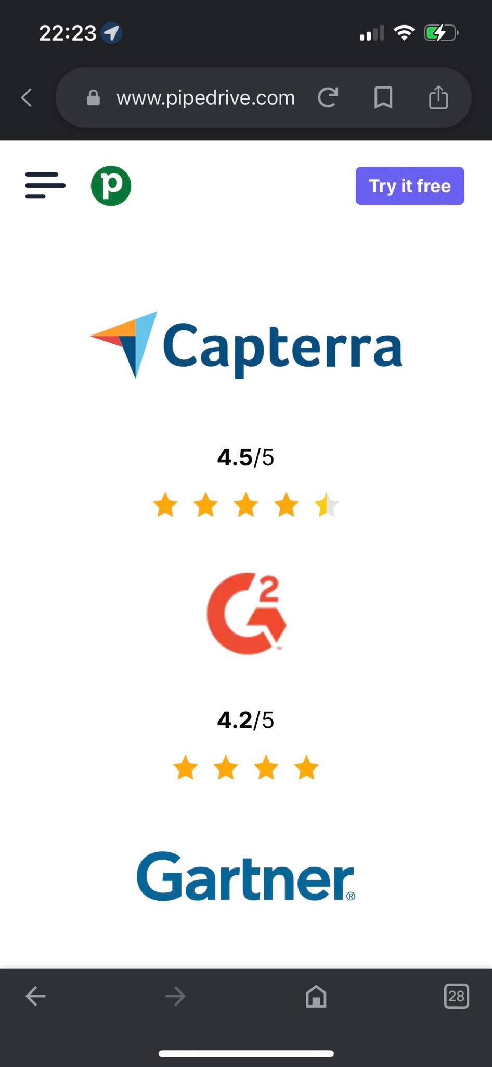

**Expected result:**

When user opens link using any mobile phone and any browser web page should open and display starting from the top sections of site showing top menu, search field and etc.

***1.6 Cross browser rendering***

During the testing **cross browser rendering** also was used. Web page was tested in such browsers like Chrome Version 109.0.5414.75 (Official Build) (64-bit), Microsoft Edge Version 110.0.1587.41 (Official build) (64-bit), Mozilla Firefox (Version 108.0.2). But no issues were found.

***Improvements***

I would like to suggest few improvements to “Pipedrive” web page to make it more convenient and qualitative

* **Referral program’s link leads to login page**

When user clicks on that link user does not expect login page, it is not clear what happens after log in. For user would be more clear to get page with information about the referral program and button/link to log in from that page

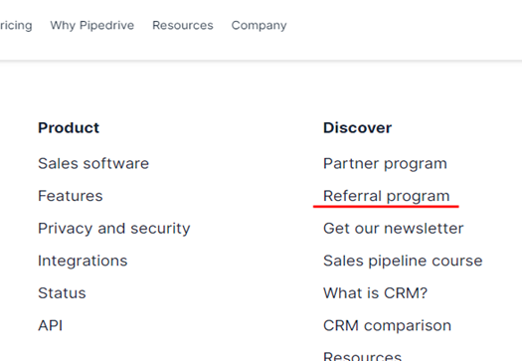

* **Brands’ logos have no description**

When user researches web site and sees logos with reviews then description is expected to these brands to understand what logos they are and what rating they have. Currently these pictures don’t give any information to the user.

1. **Web page HTML analysis**

In this task I have used manual testing and code analysis. I have checked if main functionalities of web page and expected results are met.

Also I have used additional tools to check all links of the web page and code analysis.

***Automatic discovery of broken links to pages and resources***

To check links on the web page I have used “Link checker”. (<https://validator.w3.org/checklink?uri=https%3A%2F%2Fwww.pipedrive.com%2Fen%2Ftest-task-qa&hide_redirects=on&hide_type=all&no_accept_language=on&no_referer=on&depth=&check=Check> )

Its result showed that web page contains one not working link which was tested manually and confirmed (**It was described in bug report number 5**).

Also several not working links to the empty pages were found. If you click on them they lead to nowhere. They are not shown on web page and do not have any impact to how web page is displayed, but can impact on web page’s loading etc. Link to one of them [https://www.pipedrive.com/en/width=415/https://www-cms.pipedriveassets.com/Company-logos/G2.png](https://www.pipedrive.com/en/width=415/https:/www-cms.pipedriveassets.com/Company-logos/G2.png)**.**

* 1. **Spell-checking**

Spell-checking was done by using “Spell checker” ( <https://datayze.com/website-spell-checker?domain=https%3A%2F%2Fwww.pipedrive.com%2Fen%2Ftest-task-qa&parameters=&exclude=&elementtype=limit&elements=&ignored=> ).

In the result one issue was found. This tool showed that web page contains a misspelling **“Forr”** which cannot be found by manual testing. Misspelling is in <title> element in the HTML markup. It is not visible for web page users and do not affect on them. But it can impact on web page indexing engines.

